VALUATION REPORT

Valuation Ref No | HSP25260064 | Date | 10-11-2025
Name of the panel valuer: HARIHAR S
Pursuant to the request from The Manager, Jammu and Kashmir Bank, Parrys Branch the property Land and Building situated at No. 52, (Old Nos. 115 and 116), Armenian Street, Chennai, Tamil Nadu 600 001, comprised in at Old O.S. No. 144, R.S.No.11598, Muthialpet Village, Chennai North SRO belonging to M/S JAMMU AND KASHMIR BANK inspected by me on 10-11-2025 in the presence of tenants for the purpose of assessing the fair market value of the property AS ON 11-11-2025

GENERAL INFORMATION
1 | Name of the party/owner | : | M/S JAMMU AND KASHMIR BANK
2 | Address of the property | : | No.52, Armenian St, Parrys Corner, George Town, Chennai - 600001.
3 | Name/s of the Reported owner/ name/s of persons in whose names/s the property registered and address | : | M/S JAMMU AND KASHMIR BANK
4 | Purpose of valuation | : | For Self
5 | List of documents produced for perusal | : | - Copy of Sale Deed 1884 Sq Ft of UDS out of 3354.61 Sq Ft Land in the Name of M/S JAMMU AND KASHMIR BANK vide Deed Doc No.185/2000 dated 19-09-2000.  - Copy of Layout Drawing Copy of Parking Area.
6 | Date of inspection | : | 10-11-2025
7 | Approximate Distance from the branch to the property | : | 0 km
8 | Situation/location/brief description of the land / site | : | The subject property is Commercial Property (Bank), situated in Main Road. All necessary civic amenities and shops are available nearby, and the property falls within Commercial Zone.
9 | Description of Building | : | No.52, Armenian Street, Parrys Corner, George Town, Chennai-600 001.
10 | Lat & Long | : | 13.090171555596417, 80.28810707641838
11 | Google Map Link | : | https://maps.app.goo.gl/d1XqsRvmrnz5re1P7
12 | Boundary Details of the Property as per Document | : | North by: Land in R.S No.11597  South by: Land in R.S No.11599,  East by: Land in R.S No.11610  West by: Armenian.
13 | Boundary Details of the Property as per Site | : | North by: Land & Building,  South by: Land & Building  East by: Land & Building and  West by: Armenian Road.
14 | Assuming the entire property is let out, the probable monthly rent and advance | : | Probably Rent – Rs 1,70,000 per Month ( Rupees One Lakhs Seventy Thousand Per Month )
15 | Whether the building plan has been approved? | : | Not Provided
16 | If yes, date of approval, approving authority, and whether the building has been constructed as per the approved plan at the time of inspection | : | Nil
17 | If no, the reason for non-approval | : | Nil
18 | Remarks with respect to Plan |  | The Subject of the property is Commercial Property- Jammu and Kashmir Bank Situated in (Ground Floor) Armenian Street, Parrys.  As per Document BUA is 3354.61 Sq Ft. Building.  Building Plan is not Provided for the Building. For the purpose of valuation, we will consider the Area as per Document.
A | LAND
1 | The total area (Extent of the site/Land | 1884 Sq Ft of UDS out of 3354.61 Sq Ft (as per Doc)
2 | Description of the site/land | Commercial
3 | Character of locality | Commercial Area
4 | Class of locality | Commercial
5 | Classification | Commercial Area Class I Type I
6 | Development of surrounding areas | Developed Area
7 | Is the locality subjected to frequent flooding | No
8 | Feasibility to the civil amenities like schools, hospital, offices, market etc | Nearby
9 | Shape of land | Rectangle
10 | Type of use to which it can be put | Commercial Purpose
10 | Any other restriction of usage | No
11 | Nature of right, whether lease hold | Own
12 | Road facility | Available
13 | Is it a corner plot | No
14 | Lift | Available
15 | Carpark | Available
15a | Water supply/potentiality | Available
15b | Underground sewerage system | Main Drain
16 | Any other sentimental social issue Which may affect the value. | No
17 | General remarks | --Nil--
18 | Guideline Value of Land per Sq Ft | Rs 16500 per Sq Ft (Armenian Street Post Office to Mannady Street Juction) as per TN Sub Registrar Office
19 | Total Guideline Value of Land | = 1884 x 16500 = Rs 3,10,86,000/- or Say Rs 3.11 Crores  (Rupees Three Crores and Eleven Lakhs Only)
20 | Prevailing unit market rate of land | Based on enquiries for Land it is understood that the Market Value of Land in Parrys is near Armenian Street is around 7.68 Crores per Ground i.e. Rs 32000 per Sq Ft.
21 | Adopted rate of valuation | 32,000 Per Sq Ft
22 | Total Value of land based on market value | 1884 x 32,000 = Rs 6,02,88,000 /- or Say Rs 6.03 Crores  ( Rupees Six Crores and Three Lakhs Only )

B | BUILDING
1 | Type of construction | R.C.C. Column Foundation
2 | Quality of construction | Good
3 | Appearance of the building | Good
4 | Number of floors | Ground + 2
5 | Floor in which flat situated | The Subject of the Property is Situated in Ground Floor
7 | Maintenance of the building | Good
8 | Description of the building | The subject property, located in Armenian Street, Parrys.
9 | Foundation | Column Foundation
10 | Superstructure | Brick wall
11 | Roof | RCC Roof
12 | Doors | Wooden Doors
13 | Windows | Wooden Doors with Glass
14 | Sanitary fittings | Indian/Western
15 | Flooring | Tiles
16 | Painting | The building has been Painted.
17 | Electrical arrangements | Concealed wiring
18 | Water supply arrangements | Available
19 | Sanitary arrangements | Main Drain
20 | Present stage of construction | Completed
21 | Built Up Area | 3354.61 Sq Ft as per Site
22 | Age of the building | 23 years
23 | Estimated further life of the building | 37 Years
24 | Depreciation | 37 %
25 | Other Remarks | NIL
26 | Replacement Rate of Building | As per TNPWD Schedule of Rates
27 | Development works to the land | Included part of building (Such as Planning and development charges, Electricity, Water supply

BUILDING VALUATION TABLE
Floor | Description | Area  ( Sq Ft ) | Cost per  Sq M | Year of Const. | Depreciation | Depreciated Value
Ground Floor | Commercial Unit | 3355 | 26045 | 2001 | 37% | 56,51,656
Flooring | Tiles | 3355 | 2355 | 2001 | 37% | 5,11,025
Joineries | Windows / Doors | 3355 | 614 | 2001 | 37% | 1,33,235
Modulation Works | Interior Works | 3355 | 5000 | 2001 | 37% | 10,85,105
Internal Water/Electrical/Sanitary Arrangements |  | 3355 | 2169 | 2001 | 37% | 4,70,664
External Water/Electrical/Sanitary Arrangements |  | 3355 | 2054 | 2001 | 37% | 4,45,709
Other Provisions - Car Park, Gate, Septic Tanks, Pavement, Bore, RWH, Permits |  |  |  |  | 10% | 8,29,740
Value of the Building |  |  |  |  |  | 91,27,144

Value of the Building = Rs 91.27 Lakhs (Rupees Ninety One Lakhs Two Seven Thousand Only)

LAND VALUATION TABLE

Land Extent | 1,884 | Sq Ft
Building Extent | 3,355 | Sq Ft
Guideline Value | 16,500 | Rs per SqFt
Guideline Value of Land | 3,10,86,000
Guideline Value of Building | 91,27,144
Value of Building | 91,27,144 | Rs
Adopted Market Value of Land | 32,000 | Rs per SqFt
Value of Land | 6,02,88,000 | Rs
Total Value of Property | 6,94,15,144 | Rs
Fair Market Value of the above said property | 6,94,15,144 | Rs
Realizable Sale Value | 6,24,73,630 | 90%
Distress Sale Value | 5,55,32,116 | 80%
Guideline Value of the above said property | 4,02,13,144

E | VALUERS OPINION
 | Fair Market Value of the above said property | Rs 6.94 Crores (Rupees Six Crores Ninety Four Lakhs Only)
 | Realizable Sale Value | Rs 6.24 Crores (Rupees Six Crores Twenty Four Lakhs Only) ** considering 90% of FMV
 | Distress Sale Value | Rs 5.55 Crores (Rupees Five Crores and Fifty Five lakhs Only) ** considering 80% of FMV
 | Guideline Value of the above said property | Rs 4.02 Crores (Rupees Four Crores and Two Lakhs Only)
F. DECLARATION & REMARKS
- Legal due diligence for establishing clarity of title, ownership, leasehold, rights, notices or encumbrances if any, litigation issues, notices or disputes if any and other related legal issues are not the part of the scope of this assignment.
- I have no direct or indirect interest in the above said property.
- The information furnished above is true and correct to the best of my knowledge and belief
- The extent of land and its ownership may please be verified with its latest legal opinion.
- Verifying the Authenticity of the documents such as sale deed, building plan or layout is not part of Valuer Scope.
- Value varies with purpose and time. The value should not be referred for any other purpose than mentioned above. The Valuation report is in compliance International Valuation Standards – IVS 2022

G. ANY OTHER REMARKS | NIL
Place : Chennai | Signature of the valuer

Enclosures: Guideline value, Location and Photographs

GUIDELINE VALUE PROOF

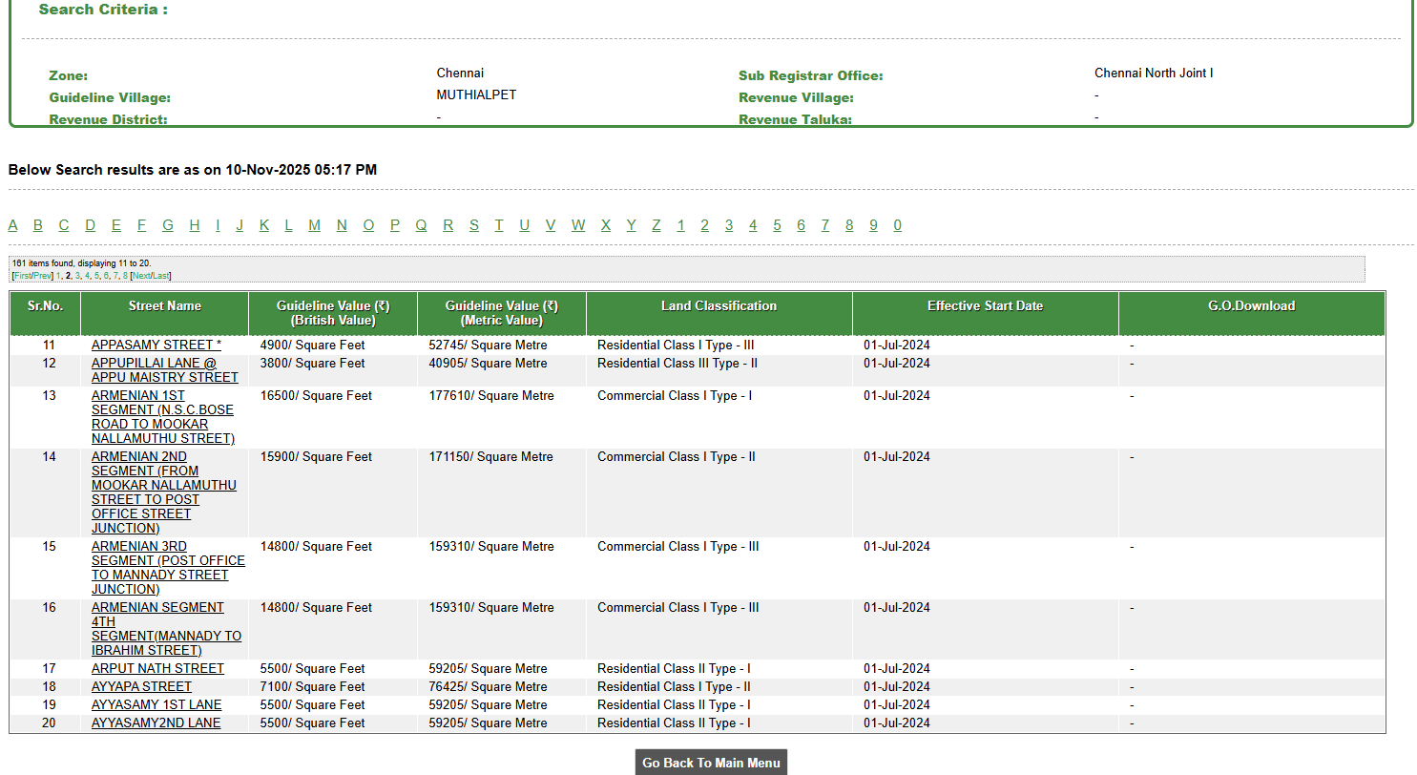

LOCATION MAP

GEO COORDINATES: 13.090171555596417, 80.28810707641838

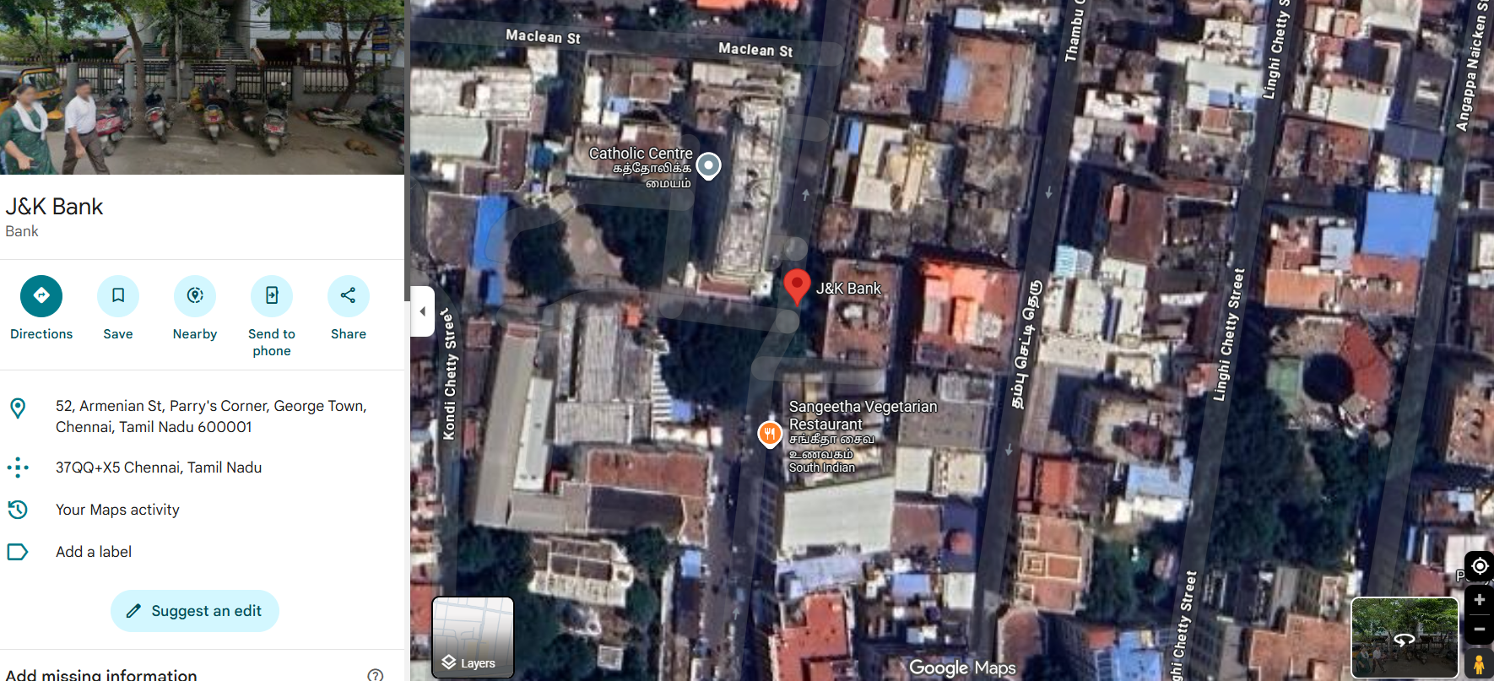

PHOTOGRAPHS
